**Lesson One: Finding the Bugs**

* In computer Jargon, the term *bug* refers to and error in a program. The process of systematically locating and fixing these errors is referred to as *debugging*.
* Three Types of errors can occur in programming:
  + Syntax errors: typographic errors (omitting a quote or misspelling a variable name)
  + Run-time errors: operations are applied to illegal values (attempting to multiply a string or divide by Zero)
  + Logic errors: flaws in design or implementation of the program(program produces the wrong result)
    - Can be the hardest to identify since they are not caught by the IDE. The program is written “correctly” without syntax errors, but the correct output is not produced
* Useful Tips for identifying errors in your programs
  + Setting breakpoints
    - At various intervals in the code,
    - You can then isolate at what point the program is going wrong
  + Using a debugger
    - Our debugger is built into the IDE
    - Beneficial because it's less productive to spend a lot of time looking for issues when a debugger would easily find little mistakes like typos.
    - A visual debugger integrated into an IDE, like we are using also gives you convenient access to smart editing and all the other features of the IDE, in a single integrated development environment (hence the name).
* Debugging is a very important and useful skill to develop. You will often make mistakes when writing code.
* Example program with error (from Section 1.3.Errors):

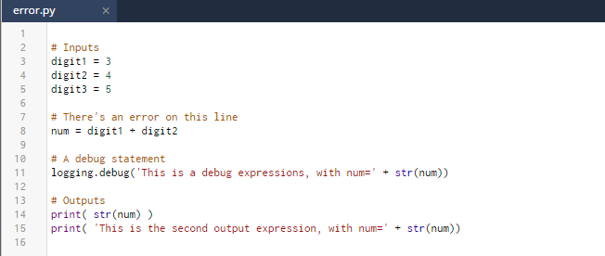

Look at the code on the left. This code contains a simple syntax error.

Now press the button below to run the code.



Once you have run the code, you will see the error appear.

## Understanding the error

The error looks quite unfriendly. However, if you read the error carefully and look back through your code, you should be able to work out what to do to fix it. Have a look at the explanation below.

This is the error message:

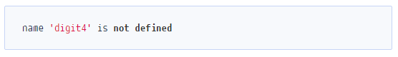

This error is telling us that that the variable digit4 is not defined anywhere in our code although we have tried to use it.

## Correcting the error

We can correct this error in two ways:

1. Define the variable digit4 in our code. To do this, we simply add a new line of code within the inputs section of our program:
   1. digit4 = 6
2. Change the variable digit4 in our code to one of the variables that we have defined. We can alter line 8 as below:
   1. num = digit1 + digit2

* Add another Example program with error and demonstrate how to correct the error:
* Challenges: Squashing the Bugs! (from section 4: Fixing Errors)

The following challenges all have errors in the code. You will need to hunt the bugs down and squash them!

Look back at the earlier page ‘1.3 Errors’ if you need to refresh your memory on how to deal with errors.

## Important

During these challenges, you might make mistakes and want the code back as it was originally. If this is the case, you can restore the contents of the two fix challenges to their original state by selecting the **‘Restore current files’** option from the **‘Settings’** menu.

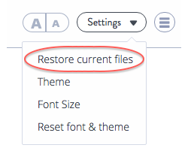

4.1 Fix Challenge 1

4.2 Fix Challenge 2